
A Division of the National Rehabilitation Association
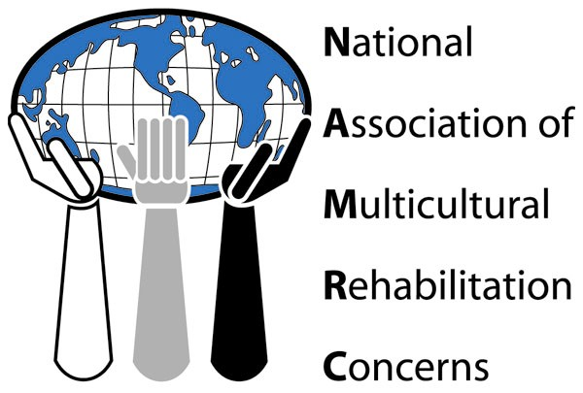

Issue and Challenge Plan Overview
Each state chapter of the Association is challenged to select one or more of the identified national issues relevant to their home state to advance one or more objectives outlined in the Association’s bylaws. States who submit a Plan by April 30, 2017 to mcbc.namrc@gmail.com will be considered to receive a $200 allotment to apply to their proposed plan. See Issue and Challenge Plan submission criteria for allotment eligibility requirements.
The mission of the National Association of Multicultural Rehabilitation Concerns is to promote cultural diversity and disability through advocacy for excellence and equity in rehabilitation research, education and practice!
The issues were identified by the Legislative Committee of the NAMRC board. The issues are as follows:
1. Educating Minority Elected Officials on Minority Disability Issues and Rehabilitation:
Statement of Issue: Representatives and other elected officials are historically knowledgeable and concerned about civil rights and human service issues affecting racial and ethnic minorities, but many times are less knowledgeable about issues of disability, rehabilitation, and persons of color; many times seeing them in competition with traditional areas of concern for racial and ethnic minorities.
Proposed legislative action: engage in a nationwide awareness campaign in local communities for minority elected officials to: (1) Make them aware of disability issues as they impact the minority community, (2) Educate them on the resources and programs in the rehabilitation industry.
Goal: Increase the knowledge of minority elected officials regarding disability and rehabilitation issues, needs, programs and resources, especially those impacting minority persons with disabilities.

2. Address the Underrepresentation of Minorities with Disabilities Receiving Services in The Rehabilitation Industry.
Statement of Issue: While persons with disabilities from culturally diverse backgrounds have a higher incidence of disabilities, they tend to be underrepresented in respect to this incidence, and in respect to the population represented in their local communities, on the caseloads of VR and other providers in the rehabilitation industry. Lack of knowledge of services and resources in the minority community appears to be a causative factor, in addition to the lower representation of minority persons in the rehabilitation professions.
Goal: Increase the number and percentage of minority persons with disabilities receiving services within the rehabilitation industry, or the knowledge and awareness of minority persons with disaibilies about rehabilitation services and programs.
Proposed legislative action: Provide a targeted education and awareness campaign to:
  - Educate faith-based and community-based organizations, e.g., churches, community centers, etc., serving various culturally diverse populations on disability and rehabilitation issues and services.
  - Educate minority owned businesses and stakeholders in the minority community about disability and rehabilitation issues and services
  - Create community awareness about legislation, access, and civil rights laws effecting persons with disabilities.
The objectives of the Association per the bylaws are:
1) To advocate on behalf of individuals with disabilities from culturally diverse populations to ensure equity, parity and quality in the delivery of rehabilitation services.
2) To provide leadership and direction in research consistent with the mission of the Association.
3) To advocate for, propose, and support legislation and policy that addresses the needs of individuals with disabilities from culturally diverse populations.
4) To foster the growth, development and career enhancement of existing and potential members through professional development, mentoring and networking.
5) To enrich the capacity of the larger rehabilitation community to better meet the needs of individuals with disabilities from culturally diverse populations through education, training and awareness.
6) To promote a more culturally diverse rehabilitation community through advocacy, recruitment and outreach.
Issue and Challenge Plan Submission Criteria for consideration of $200 allotment. Issue and Challenge plan must:
- Promote the mission of the Association
- Clearly connect to one or more objectives of the Association
- Outline activities to achieve objectives
- A plan to evaluate the effectiveness of activities used to achieve objectives.
All submissions received by the deadline will by the NAMRC board. Those submissions that meet the criteria as evaluated by the NAMRC board will be notified via email by () of the award and the process to receive the allotment. Lastly, state chapters who submit an Issue and Challenge Plan are strongly encouraged to provide quarterly reports to MCBC to include in the NAMRC Newsletter and update website.

Issue and Challenge Plan

General Chapter Information

NAME of Chapter:

Year of Plan:

State Chapter President Contact information: (Please include name/address/email/NRA number)

List of chapter officers with emails and phone numbers (such as president, vice-president)

List of Committees with chairs emails and phone numbers

State NRA Chapter Officers information: (Please include name/address/email)

Issue Information

Selected Issue:

Explanation of how issue promotes the mission of the Association:

Selected Objectives:

Challenge Plan Information

Action Plan:

Explanation of how action plan will achieve selected objectives:

Evaluation of Activities (attached any surveys/assessments the chapter intends to use)

Explanation how evaluation activities are intended to measure the achievement of the selected objectives:

