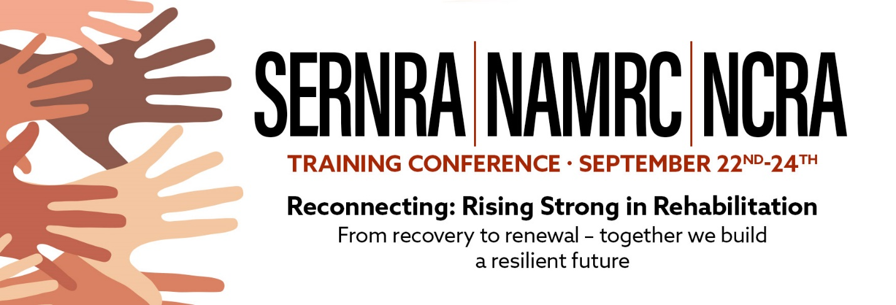

Cheryl Revels, President of SERNRA, Dr. L’Tanya Fish, President of NAMRC, and Toni King, President of NCRA. The Southeast Region National Rehabilitation Association (SERNRA), National Association of Multicultural Rehabilitation Concerns (NAMRC), and the North Carolina Rehabilitation Association are all under the head organization: National Rehabilitation Association.
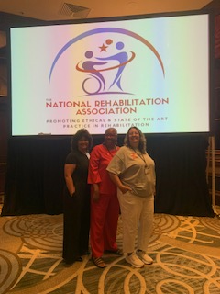

NAMRC Board of Directors voted unanimously to partner with our counterparts to conduct an in-person conference at the Sheraton Four Seasons in Greensboro, North Carolina. NAMRC sponsored the 3-hour Ethics Pre- Conference title:

Beyond Competence: Ethical Implications of Counseling Men.
Pre-Conference Panelists

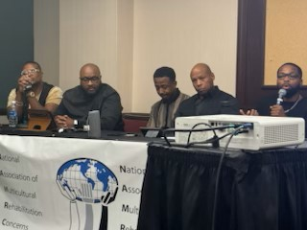

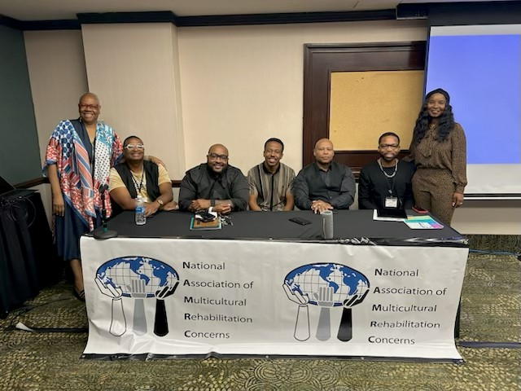

Left to Right:
Dr. Fish, NAMRC President,
Dr. Phillip D. Lewis,
Mr. Xavier Fullerton
Mr. Andrew Watkins
Dr. Shon D. Smith,
Dr. Mel Johnson-Norwood,
Dr. Keisha G. Rogers, NAMRC Immediate Past President

Moderators
Dr. Keisha Rogers
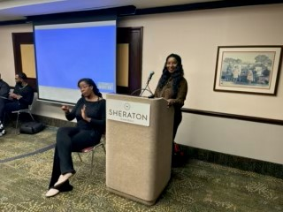

Dr. Nyree Cunningham Pullen
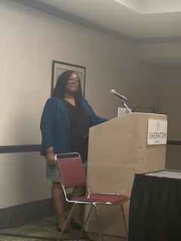

NAMRC Exhibit Table

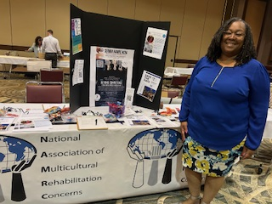
Dr. Nyree Cunningham Pullen, NAMRC Board Member

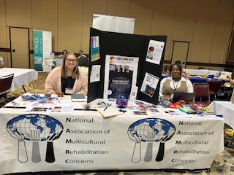

Bethanny King, and Laini Wright
Rehabilitation Counseling graduate students from Winston Salem State University

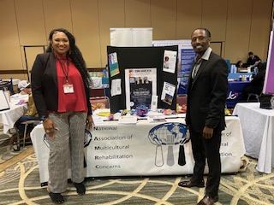
Andrea Sneed and Lahmi Simmons,
Rehabilitation Counseling graduate students from Winston Salem State University

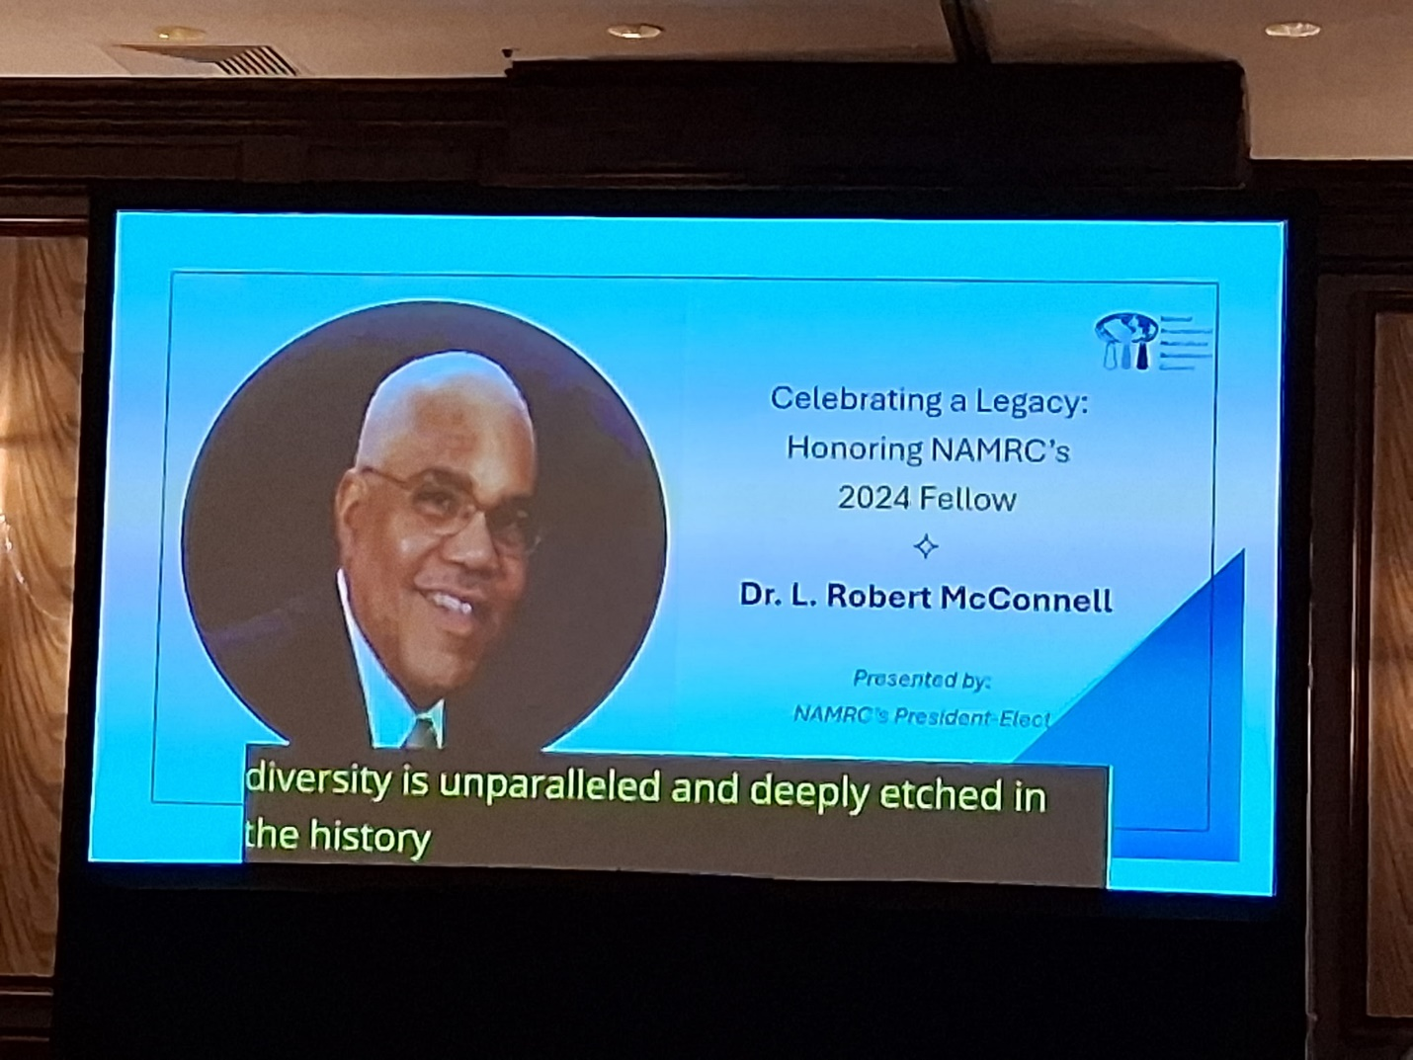

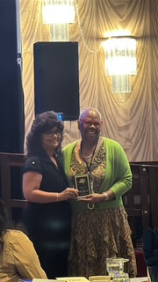

Southeast Region National Rehabilitation Association Award
H. B. Cummins Award
Dr. L’Tanya (Terrye) Fish
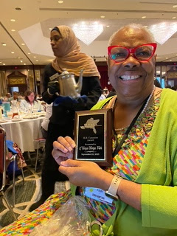

SERNRA NAMRC NCRA Program Book

https://online.fliphtml5.com/ktrrw/kcfn/



Opening Ceremony
Mayor Nancy Vaughan, Mayor of Greensboro
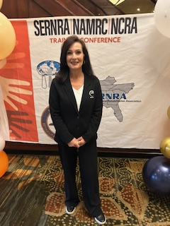

Chris Egan, Assistant Secretary for Employment and Community Access for the NC Department of Health and Human Services

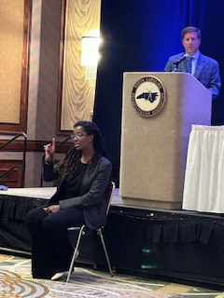

Introduction of Speaker - Kathie B. Smith, Division Director, Division of Employment and Independence for People with Disabilities
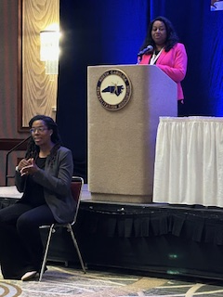

Keynote Speaker (CRC/CEU 1.0)
Ms. Ashlea Lantz, Policy Fellow, Council of State Administrators of Vocational Rehabilitation (CSAVR) and Certified Rehabilitation Counselor (CRC)

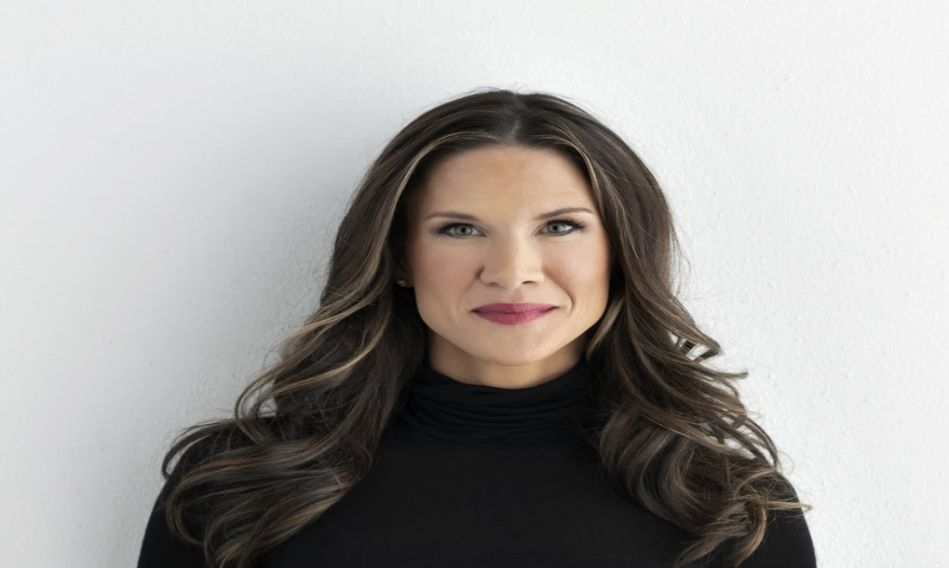

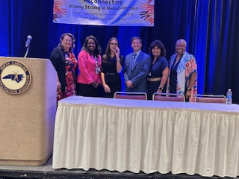

Concurrent Sessions
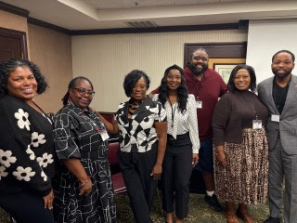

Pathways to Employment: Leveraging Your CRC Credential

Left to Right:
Ms. Cecilia K. Hagley, University of North Carolina at Wilmington
Ms. Del Savage, NC Division of EIPD
Ms. Danielle Clark Moore, Moore Ways to Success, LLC
Dr. Keisha Grayson Rogers, Winston Salem State University
Dr. Quintin Boston, University of District of Columbia
Dr. Paige Dunlap, North Carolina A & T State University
Dr. Mel Johnson-Norwood, Winston Salem State University

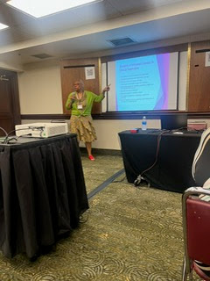

Ethics and Clinical Supervision
Dr. L’Tanya Fish
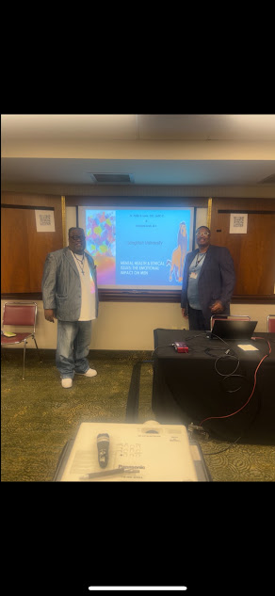

Mental Health & Ethical Issues: The Emotional Impact on Men (Ethics)
Dr. Phillip Lewis, Langston University
Mr. Emanuel Lewis, Liberty University

Poster Session

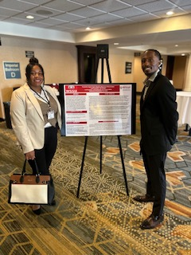

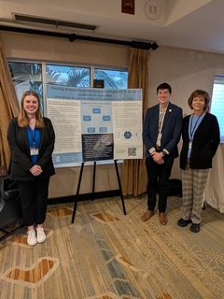

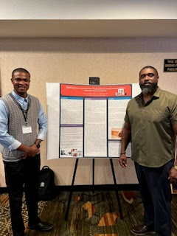

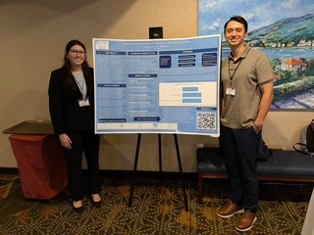

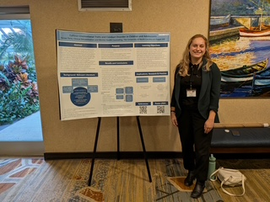

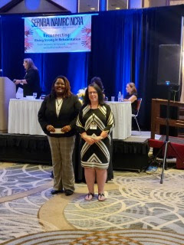

T.L. McClellan Scholarship Winners
Marissa Bumgarner
Elizabeth Brooks
Legislative Update

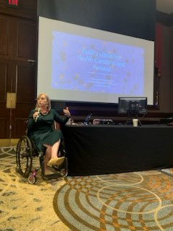

Julia Adams - Scheurich, President of Oak City Government Relations

NAMRC Members
