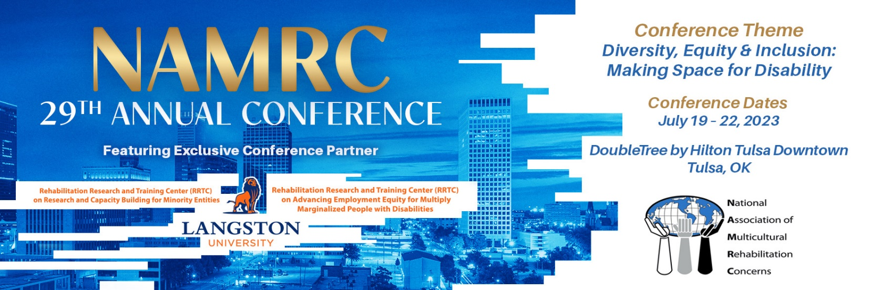
PROPOSAL SUBMISSION DEADLINE
Extended to May 22, 2023
NAMRC PRESIDENT:
Keisha G. Rogers, Ph.D., CRC, LCAS, LCMHC, QS, ACS

CONFERENCE CHAIRS:  Courtney Ward – Sutton, Ph.D., CRC  Katavia Sloan, MS, CRC, LPC, CCM | PROGRAM CO-CHAIR:  DeAnna Wilson, Ph.D., LPC, NCC, CRC  Cecilia Hagley, BSW, Student Representative

The National Association of Multicultural Rehabilitation Concerns (NAMRC) is pleased to announce the 2023 national training conference, “Diversity, Equity, & Inclusion: Making Space for Disability”. NAMRC is currently inviting the submissions of proposals from rehabilitation practitioners, administrators, educators, students, researchers, and consumers that address evidence-based practices and multicultural issues. Please carefully read the following guidelines to submit a proposal for a concurrent session, symposium (panel), or a poster. Send proposals to namrcconferenceproposal@gmail.com.

Content Areas of Presentation
The committee seeks proposals which address the conference theme “Diversity, Equity, & Inclusion: Making Space for Disability”. This year’s theme focuses on diversity, equity, & inclusion, and “how to” sessions to build space and conversations for disability. Proposals are strongly encouraged that involve new ideas, devices, methods, programs, or innovative opportunities for people with disabilities from diverse backgrounds. As the rehabilitation counseling field transforms, we must ensure that multicultural issues in rehabilitation remain a priority despite the ever-changing socio-political climate of the nation.

CRCC Content areas include:
- Professional Orientation – Legal, Diversity and multicultural counseling, etc.
- Counseling Theories, Techniques, and Evidence-Based Practice
- Cultural Diversity
- Group and Family Counseling
- Crisis and Trauma Counseling and Interventions
- Medical and Psychosocial Aspects of Chronic Illness and Disability
- Assessment, Occupational Analysis, and Service Implementation
- Career Development and Job Placement
- Demand-Side Employer Engagement – ADA, workspace modifications, human resource practices, etc.
- Community Resources and Partnerships – community rehabilitation providers, social security programs,
mental health, corrections, substance abuse services, independent living services, etc.
- Case Management – advocacy, negotiation, mediation, and conflict resolution, etc.
- Health Care and Disability Management – Medicare, Medicaid, workers’ compensation, insurance, etc.
- Research, Methodology, and Performance Management

SUBMITTING PROPOSALS FOR ETHICAL PRACTICES
The content of the program must convey specific behavior that is related back to, preferably, the CRCC Code of Professional Ethics for Rehabilitation Counselors or, alternatively, the ACA Code of Ethics and Standards of Practice and properly cited within the presentation by:
1. Referencing the Code of Ethics within the abstract, program description, and a minimum of one (1) learning objective.
2. Providing a written statement outlining the way the codes will be used and what they will address.
3. Minimum of three (3) learning objectives. If you are submitting an ethics proposal one (1) of the learning objectives must specifically reference the Code of Ethics.
4. Send proposals to namrcconferenceproposal@gmail.com.

Appropriate subject matter must relate to rehabilitation counseling and must include one of the following:
• The counseling relationship.
• Confidentiality, privileged communication, and privacy.
• Ethics and Diversity or Culture
• Advocacy and accessibility.
• Professional responsibility.
• Relationships with other professionals and employers.
• Forensic services.
• Assessment and evaluation.
• Supervision, training, and teaching.
• Research and publication.
• Technology, social media, and distance counseling.
• Business practices; or
• Resolving ethical issues.

POSTER PROPOSAL FORM

POSTER TITLE
In the space below, limit your title to 12 words, including punctuation marks and spaces. Proposal titles should be simple and factual.
POSTER ABSTRACT
Limit to 150 words max in the space below. An abstract is a brief, comprehensive summary of the contents of the article.

POSTER LEARNING OBJECTIVES
Learning objectives (minimum of three), (e.g., audience will be able to describe appropriate language use for population, audience will be able to evaluate for safety, and audience will recognize challenges of researchers of color)
CONTENT NARRATIVE OR DESCRIPTION OF TOPIC
MULTICULTURAL REHABILITATION FOCUS (Related to the conference theme)
REFERENCES (list at least 5 references within the last 7 years)
Biography of the Lead Presenter (no more than 50 words) & Co-Presenters (no more than 50 words for each co - presenter):
Below, in a brief paragraph, give the lead presenter’s qualifications. Please list degree(s), areas of specialization, current position, and employer.

PRESENTATION (CONCURRENT) PROPOSAL FORM

Type of Presentation
Concurrent Session: Individual presentations, which provide the opportunity for individuals (one or more) to present a paper, project, or other initiative. Individual presentations may be grouped with other individual presentations with similar topics or themes. Presentations are 75 minutes in duration.
Proposal Title
In the space below, limit your title to 12 words, including punctuation marks and spaces. Proposal titles should be simple and factual.
Proposal Abstract
Limit to 150 words max in the space below. An abstract is a brief, comprehensive summary of the contents of the article.
Presentation (note: this will be used as summary for the program book)
a) Presentation Description: Briefly describe how your presentation ties into the conference theme.
(50 words or less)
b) Learning objectives (minimum of three), (e.g., audience will be able to describe appropriate language use for population, audience will be able to evaluate for safety, and audience will recognize challenges of researchers of color)
d) Multicultural Rehabilitation Focus, ALL presentations must include multicultural rehabilitation counseling.
Biography of the Lead Presenter (no more than 50 words) & Co-Presenters (no more than 50 words for each co - presenter):
Below, in a brief paragraph, give the lead presenter’s qualifications. Please list degree(s), areas of specialization, current position, and employer.
Lead Presenter (only one):
The lead presenter is also the contact person and chair. Lead presenters are responsible for notifying all other co-presenters of acceptance, rejection, scheduling, and any other information provided by NAMRC. Other responsibilities of the lead presenter include:
- Be available to present the program on any day of the conference.
- Not charge a separate fee for attending your session.
- Pay the registration fee to attend the conference one month before early bird to have your session posted in the program.
- Present at only one session, additional poster submissions are exempt.
- Make presentation materials and activities accessible to participants who have sensory, motor, or other disabilities.
Lead Presenter name, credential(s), and professional affiliation will appear EXACTLY as you have provided in your proposal for the program booklet should your proposal be accepted for the conference. Please include the following in the space below:
- Name
- Email address
- Primary mailing address
- Credentials
- Daytime and evening telephone numbers
Co-Presenter(s):
List all co-presenters.
Provide the following information for each presenter at the time of proposal submission in the space below:
- Name
- Email address
- Primary mailing address
- Credentials
- Daytime and evening telephone number

